The PaperCut MacOS X App

To install the PaperCut NG client software:
- Open the Finder and select Go -> Connect to Server....
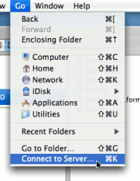
Figure 28.10. Connecting to a Windows server
- Enter smb://servername/pcclient where servername is the name of the server hosting PaperCut NG.
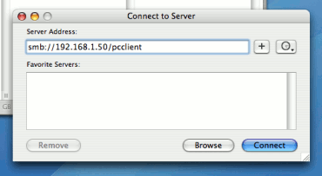
Figure 28.11. The PCClient share's connection string
- Drag the PCClient application across to the local Applications directory.
- Open System Preferences... from the Apple menu.
- Select Accounts.
- Click the Login items tab.
- Click the + button and select the newly installed PCClient application.
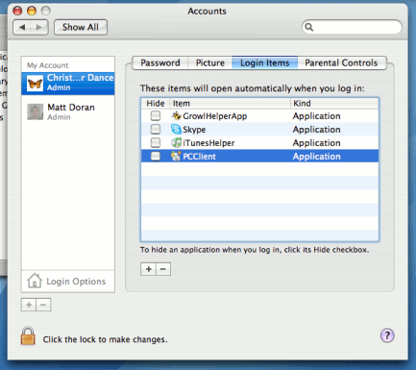
Figure 28.12. Add PCClient as a Login Item
- Restart the system and ensure the client starts upon login.

Mac Client with Popup Authentication
Schools and universities often have Macs available for student use in dedicated computer labs. In these environments the Macs are shared by many users and Scenario One is not appropriate. Larger Mac networks already using LDAP or Active Directory authentication, or planning on doing so, may wish to consider Scenario Three explained in the next section.
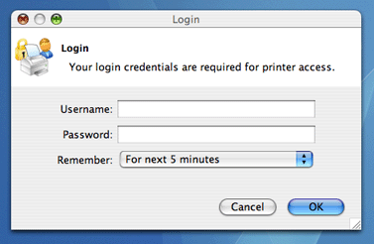
Figure 28.13. Mac popup authentication dialog requesting username and password
This scenario uses a popup authentication model. This is discussed in detail in the section called “Popup Authentication” and discussed further below:
The end-user's perspective:
- The user sees the client tool (PCClient) running.
- When the user prints a job, the client pops up a window requesting the user to enter a username and password. See the section called “Popup Authentication”.
- The user enters a domain username and password.
- If the credentials are valid, the job is charged to the user account.
The explanation:
- The print event is performed as a generic user - for example "macuser", "student", etc.
- In PaperCut NG, the "macuser" account is set up to use popup authentication by enabling the option Unauthenticated user. See the section called “Popup Authentication” for further details.
- The popup requests the user to enter a username and password.
- The password is authenticated and printing is charged against the supplied account.

