The PaperCut iPad / iPhone App (iOS app)
The PaperCut App for iPad / iPhone is required for printing to PaperCut managed printers as it provides authentication (linking up users with their print jobs).

Deployment
Deploying the App to iOS devices is simply a matter of having the user access the URL http://printmon.dcps.net:9191/ios/install. (This App is NOT in the iTunes store, you can only get it at this link.)
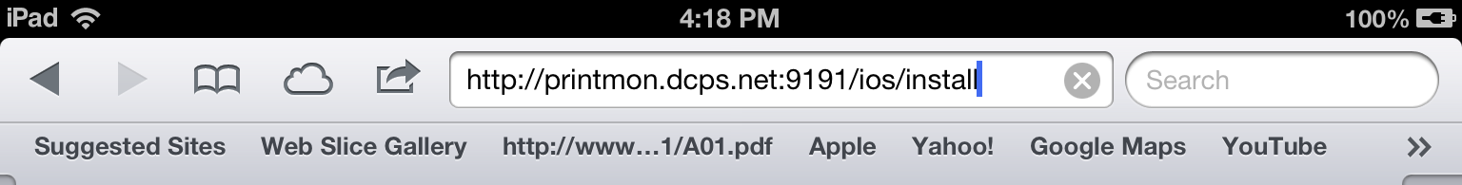
Figure 1. Accessing the installation URL manually, using Safari
After accessing the installation URL on an iPad / iPhone (iOS device) an Install Profile dialog should appear. Follow the promps to install the App. Afterwards, a Printing App (actually a Web Clip) should be available on the home screen.
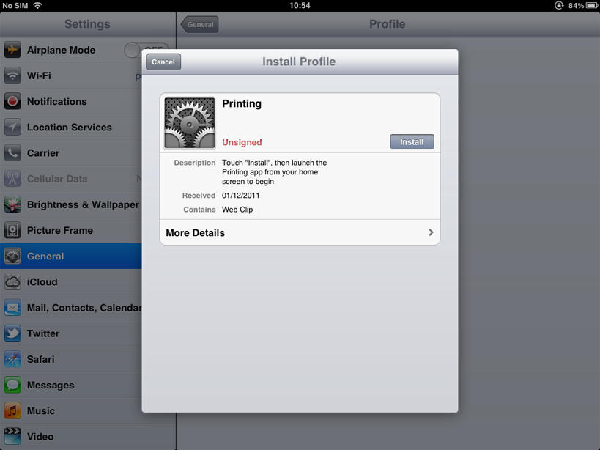
Figure 2. The "Install Profile" dialog, displayed after accessing the installation URL
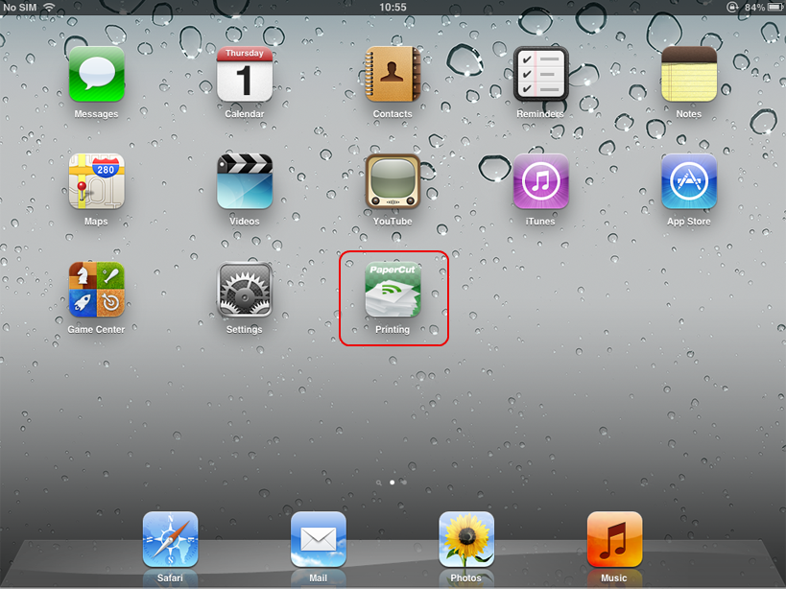
Figure 3. The PaperCut App for iPad on the home screen

Usage
The PaperCut App for iPad / iPhone is used to:
- Authenticate the user and their print jobs.
- Display the user's balance.
- Perform print job confirmation.
- Perform other functionality such as message notification.
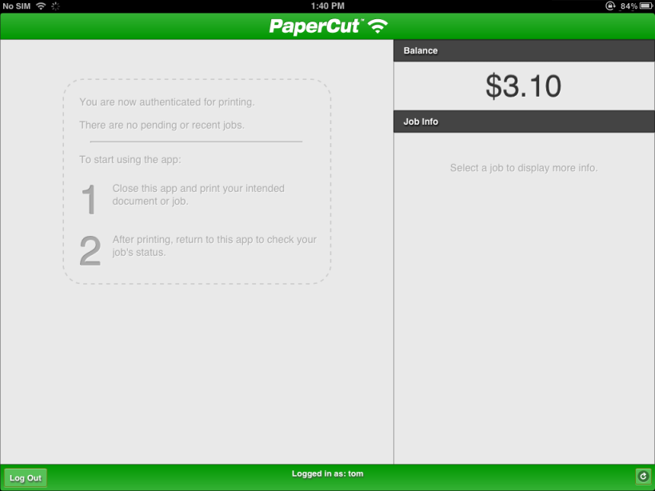
Figure 4. The PaperCut App for iPad (before printing)

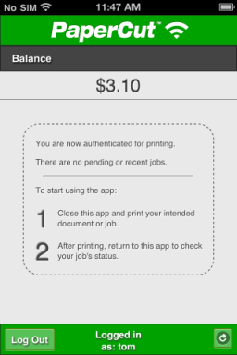
Figure 5. The PaperCut App for iPhone(before printing)

Printing
- The user prints from their selected app.
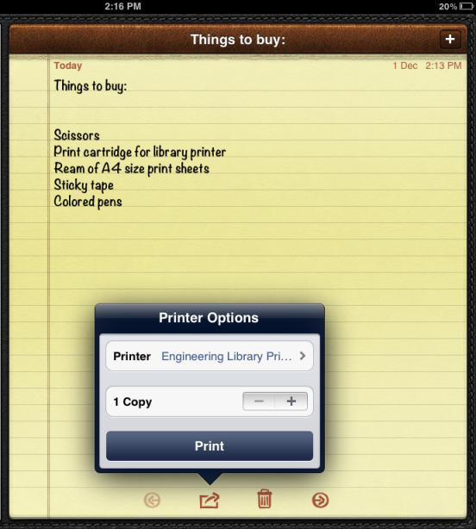
Figure 6. Printing from iOS
- The user closes the app and opens the Printing (PaperCut) app.
Figure 7. Printing (PaperCut) app on the home screen
- The user enters their username and password. On a personal device this step only needs to be performed once. Future logins are performed automatically through the use of an authentication cookie.
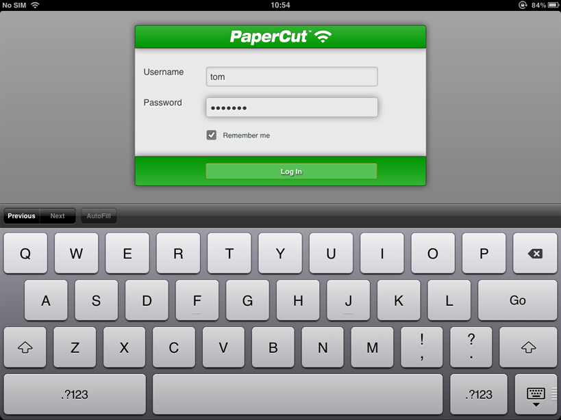
Figure 8. Authenticating to the PaperCut iPad App
- The student's print job is authentication and proceeds to print. The student can see their job's progress in the app.
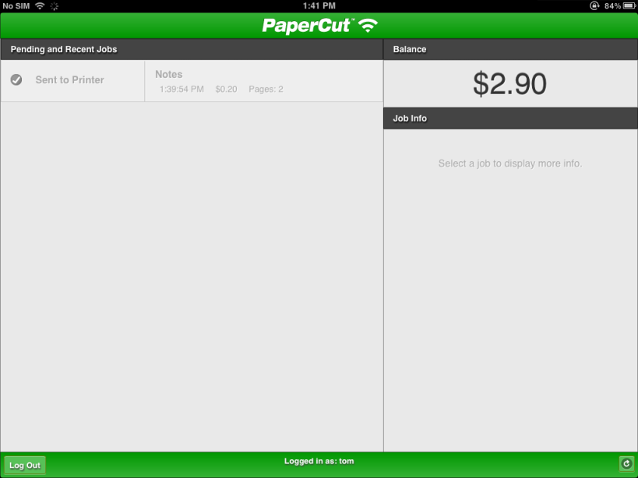
Figure 9. The PaperCut App for iPad (after printing)
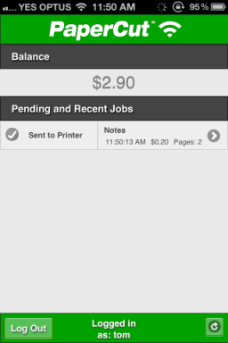
Figure 10. The PaperCut App for iPhone (after printing)

